Society Soon to Take a Dip
in the Plastic Pool
By Simona Radeva
Published: December 17th, 2015
A Continent-sized Garbage Mass Corrupting Oceans Calls for Immediate
Action, Neutralization and Filtration as the Two-step Plan for Success
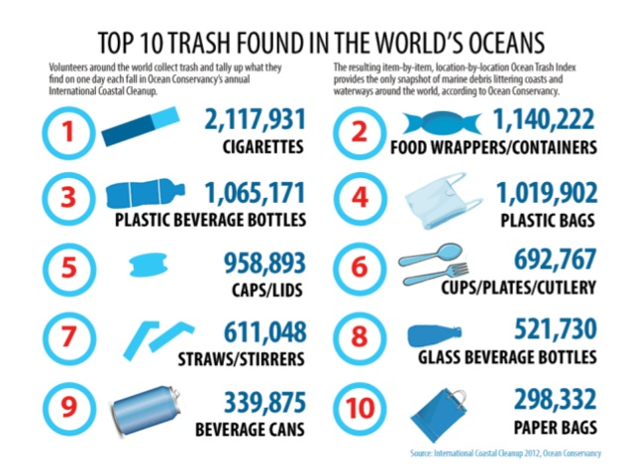
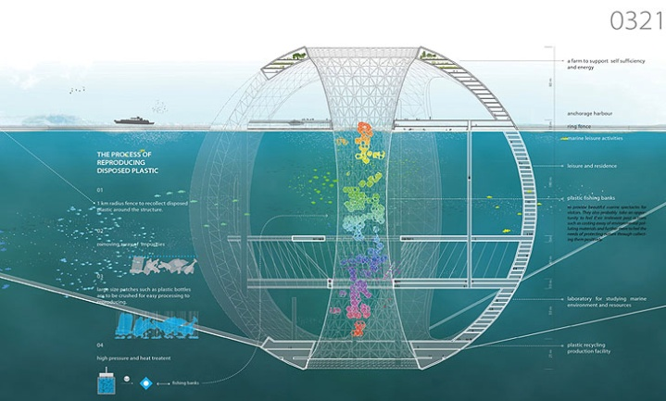
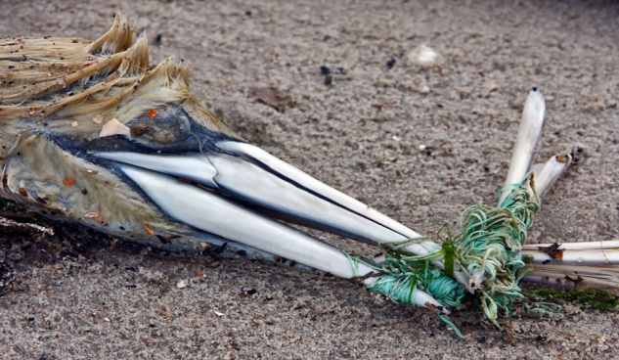
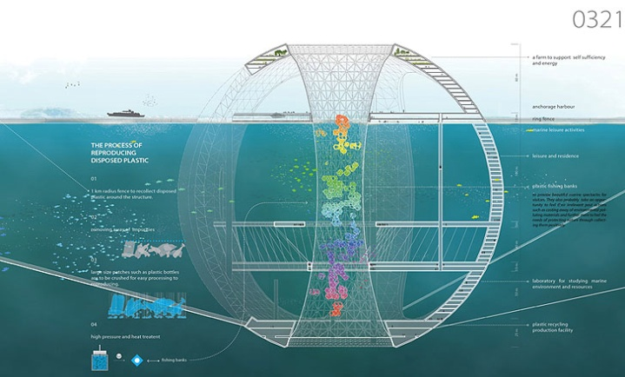
Have you ever thought about what happens to every tiny piece of rubbish after you dump it in the trashcan, or even worse, on the ground? The truth is, the plastic bottle you throw away doesn’t simply vanish into thin air. Instead, it remains a burden among many others to be carried by our planet.
Stretching in the middle of the Pacific Ocean, not far from the coasts of Hawaii, California, and Japan is the Great Pacific Garbage Patch, the greatest accumulation of industrial and household waste on Earth. Because of the rapid advance of manufacturing industries and the development of the consumer society, mankind has been unconsciously polluting the environment for years. Garbage of various kind and origin is being poured into the oceans either by the sewage systems of highly populated cities, or by ships. In this contaminated mixture you may find everything, from fishing nets to old toys, but most of all, plastic. Invented in the late 20th century, the close to non-biodegradable material has thoroughly revolutionized the way we live. We use it for practically everything and then we ignorantly throw it away, conscious that we can buy more whenever we want to and keep the vicious circle going. Once the discarded plastic reaches an ocean, it is collected in a centralized zone by water gyres, massive vortexes caused by the collision of opposite currents. (Spross, 2015) It’s hard to imagine the dimensions of that floating mass of marine debris, but what’s more troublesome is the fact that plenty of people are oblivious to its existence. The Patch was first discovered by Captain Charles Moore in 1997, who started a sequence of expeditions
concerned with understanding its impact on the ocean ecosystems. In fact, plastic has invaded those ecosystems and started to merge with
representative species, “In the central North Pacific Gyre, pieces of plastic outweigh surface zooplankton by a factor of 6 to 1.” (Moore, 2008) With that in mind, we can infer that the Great Pacific Garbage Patch is a threat to both marine life and mankind. The older the plastic floating in the ocean gets, the smaller it becomes as it photodegrades when exposed to sunlight. That results in microplastics being created, pieces that are easily digested by fish and get stuck in their organs. Ocean ecosystems provide habitats for various species that all depend on each other in one way or
another. Therefore, plastic spreads from one
marine animal to another, in accordance to the
food chain order. Another issue is about the so called persistent organic pollutants, a type of chemical waste that is absorbed by plastic and released in the tissues of sea creatures to cause damage to their body systems. Those pollutants then reach our bodies through the seafood we consume and may lead to conditions such as diabetes and obesity.
(Sun, 2013) Among all the garbage there
is also a large amount of disposed fishing gear that animals get trapped in. Fishing nets, for instance, are able to destroy whole ecosystems of corals by tearing them off as they slither along the ocean floor.
Marine pollution has always been a highly underestimated global issue. People often deny the problem and act as if it doesn’t exist, because they have adapted to their life in plastic without thinking about the aftermath. Therefore, the single solution to diminishing the Patch hides within the problem itself - the human race. Whatever we attempt to do will be a lost cause if we keep on ‘feeding’ the toxic mass with more and more garbage, so the first step towards getting rid of it is preventing it from expanding. This should happen first by installing the idea that they should live in regard to preserving the planet and their future in the mindset’s of the new generations. The government should start by putting a ban on the use of plastic bottles in all schools. Then, a crucial element is that people start following the ‘reduce, reuse, and recycle’ approach to reduce their plastic footprint, reuse the plastic they’ve already used, and promote recycling as a way to reduce waste. Still, people will be ineffective all by themselves. Businesses that are a part of the plastic industry must be restricted by the government and only produce or sell plastic if they have an introduced system of collecting the plastic and recycling it after it has been used by consumers. This will result in less plastic being resorted on ships, travelling towards the closest landfill. Plastic rarely reaches any landfill and ends up in the ocean where all it can do is wait to be disposed. Despite having a little to none plastic waste production, the one that is already in the ocean demands to be picked up. The second step of defeating the Patch is using innovative methods to filter the ocean as
well as possible. Humans may be pretty effective, but in the case of cleaning a garbage ‘island’ twice the size of Texas, they’re simply not enough. (McCormick, 2015) The Plastic Fish Tower is a spherical underwater skyscraper created by a team of Korean scientists, that aims to vacuum plastic pieces from the Patch and reprocess them. After the process is complete, plastic will emerge as tiny flakes and be used to build fish farms. (Zimmer, 2014) In order for the Plastic Fish Tower project to be put into effect, it first
Picture 1. Volunteer research shows the overall variety of waste found in the World’s oceans, also called the Ocean Trash Index. (CBC)
“We know that when we protect our oceans we’re protecting our future.”
– Bill Clinton

Picture 3. The Plastic Fish Tower – an underwater structure that effectively turns plastic into tinier pellets, used for building fish farms.
Picture 2. Birds and marine animals tend to get tangled in abandoned fishing gear, sometimes called “ghost gear” and struggle for their lives.
needs to be sponsored by the government, but
one thing is sure, it needs to be given a chance.
Humanity should be given a chance to realize
the future is sustainable and is in their hands.
When it comes to taking action, people
ask themselves the question of why they should
care. The answer is simple, because unlike humans,
the planet can’t throw away what she doesn’t
need. When there is no more oil left to turn into
plastic, mankind will turn to the Earth asking for
salvation, but will get nothing but what they’ve
given - ignorance. So next time you go shopping,
take a reusable bag and say no to the cashier
offering you a plastic one. Unless we begin
thinking holistically and rationally, we will
eventually face extinction in the plastic world
we created for ourselves.

Work Cited
International Coastal Cleanup. "Top 10 Trash Found in the World's Oceans."CBC News. Ocean Conservancy, 2012. Web. 17 Dec. 2015.
Kostigen, Thomas M. "The World's Largest Dump: The Great Pacific Garbage Patch." Discover. Kalmbach Publishing, 10 July 2008. Web. 17 Dec. 2015. <http://discovermagazine.com/2008/jul/10-the-worlds-largest-dump>.
McCormick, Mark. "How the Great Pacific Garbage Patch Is Destroying the Oceans and the Future for Marine Life." One Green Planet. One Green Planet, 4 Mar. 2015. Web. 17 Dec. 2015. <http://www.onegreenplanet.org/environment/great-pacific-garbage-patch-is-destroying-the-oceans/>.
Moore, Charles J. "Choking the Oceans With Plastic." The New York Times. The New York Times, 25 Aug. 2014. Web. 17 Dec. 2015. <http://www.nytimes.com/2014/08/26/opinion/choking-the-oceans-with-plastic.html>.
Murch, Craig. "The Great Pacific Garbage Patch Solution."Magicseaweed. Magicseaweed, 29 May 2015. Web. 17 Dec. 2015. <http://magicseaweed.com/news/the-great-pacific-garbage-patch-solution/7615/>.
Plastic Paradise. Dir. Angela Sun. Perf. Angela Sun. 2013. DVD.
Spross, Jeff. "The Surprising Economics of the Great Pacific Garbage Patch." The Week. The Week, 27 Feb. 2015. Web. 17 Dec. 2015. <http://theweek.com/articles/541440/surprising-economics-great-pacific-garbage-patch>.
Zimmer, Lori. "Spherical Underwater ‘Fish Tower’ Recycles Debris From The Great Pacific Garbage Patch." The Mind Unleashed. The Mind Unleashed, 17 Apr. 2014. Web. 17 Dec. 2015. <http://themindunleashed.org/2014/04/spherical-underwater-fish-tower-skyscraper-recycles-debris-great-pacific-garbage-patch.html>.

