An insight into Greenpeace and their advertising campaigns: where language and imagery meet manipulation
Extended Essay
Studies in English Language and Literature
Research Question: In what ways and to what extent does Greenpeace effectively use language and imagery in their advertising campaigns and marketing strategies to promote their beliefs and gain the support of the public?
Word Count: 4000

Contents
1. Table of contents.............................................................................................2
2. Introduction.....................................................................................................3
3. Advertising as a way to influence people........................................................4
4. Greenspeak – what is it and how does it play a role?......................................4
5. Greenspeak versus Newspeak..........................................................................6
6. Looking at Greenpeace adverts through a textual lens....................................8
6.1. Semantics..........................................................................................8
6.2. Graphology........................................................................................9
6.3. Use of language.................................................................................10
7. Looking at Greenpeace adverts through a contextual lens...............................11
8. Evaluation of impact.........................................................................................12
9. Conclusion........................................................................................................13
10. Works Cited......................................................................................................15
11. Appendices......................................................................................................17

Due to the fast growing pace of industrialization in today’s society and the mass culture of ignorance, environmental degradation has become an even more urgent issue that calls to be mitigated. There are a variety of ways in which large-scale problems like this one can be addressed, however, the most effective ones today are related to media coverage and publicizing. Environmental organizations all around the world are currently trying to reach out to the public and raise awareness of environmental issues and how to effectively tackle them. The extent to which those attempts have been successful however is yet a subject of ambiguity, since there are not many signs of change visible. One of the largest participants in the environmental movement towards ecological conservation and sustainable development is Greenpeace, an international non-governmental organization that organizes global campaigns which aim to raise awareness of alarming environmental issues and evoke general concern within the public. One might begin to wonder what is it that makes this organization different from the rest. Greenpeace promote their ideas in the medium of advertising. However, what is more is they do so using provocative, powerful language and visual imagery, an approach to environmentalism that appeals to the public by being more radical and extremist than the average. Creative provocation is especially important for Greenpeace, since their main aim is to evoke a response and provide a “push” towards action. What this essay will examine are the ways in which Greenpeace uses both language and visuals to raise awareness of environmental issues and the extent to which those ways are effective in their purpose. In order to better achieve that objective, this essay will provide a selection of Greenpeace adverts, as well as an in-depth analysis of how each of them use linguistic and visual features to better communicate the company’s overall messages. Greenpeace has mastered the means of persuasion and is even considered to be practicing a subtle, obscure type of manipulation established through their rhetorical strategy. However, this view is to be explored by looking at the historical and cultural context behind Greenpeace’s motivations and approaches.
The main method through which Greenpeace communicates their messages, as mentioned, is through well thought out and designed advertisements and publications, highly controversial in their nature due to the wide spectrum of features to consider in order to understand what makes them persuasive, and whether they are actually persuasive. The content of most advertisements is generally easy to intake and understand by the viewer, which makes it an adequate way to provide information about a subject. A piece of advertising by itself does not seem complex, however, it is a combination of many factors which altogether are meant to provoke a particular, often emotional response within the viewer. An important question to be discussed is whether “advertising is information or persuasion”, since it is believed that advocates of advertisements that are more persuasive than informative are generally people looking for some sort of economical support in advertising and are dependent on it for media publicity (Marquez 1977). Persuasion, on a different note, has often been associated and used interchangeably with the word manipulation. In the case of advertising, manipulation happens through language and is used to convince people to buy or support a particular product or idea. In Greenpeace’s case, however, it is not a product being advertised, but rather the company’s mission and global campaigns. Greenpeace is looking for both financial and social support, which is why the line between advertising through providing information and through exercising a sort of persuasion or manipulation is not as distinct.
An important feature to consider when speaking about Greenpeace and the ways they use rhetoric in their marketing campaigns is Greenspeak, the language of environmentalists. Greenspeak is originally defined as the jargon used by the people or groups of people who campaign for the preservation of the environment and its resources. Just like any other language system, it comes with its own particular conventions and implications, supremely important for the way Greenpeace and other organization with similar aims communicate their ideas. Although it is just a constitution of words and phrases, all of the words and phrases associated with Greenspeak have specific connotations that serve a purpose when used in a certain context. According to the Greenspeak Glossary of Terms used in the Green Business, “This guide will help entrepreneurs become more familiar with the basic terms and concepts of the green economy. This will help them successfully launch and scale their businesses, and communicate effectively about the social and environmental impacts of their efforts” (Green For All 2010). Many of the terms included in the glossary are often used by Greenpeace in their promotional materials, with careful consideration about the manipulation of space and meaning when put into context. Greenpeace does not only communicate in Greenspeak, however, it uses the jargon to emphasize on the scientific aspect of environmental protection and of course “successfully market their products and services” (Green For All). An example of two commonly used Greenspeak phrases which, while used interchangeably by others, are differentiated by Greenpeace, are “global warming” and “climate change”. Even more so, “climate change” might be considered as an euphemism for “global warming”, or in other words a more subtle, even indirect way of referring to it. The phrase that Greenpeace uses is “global warming”, for the exact reason that “global warming” has a sharper, more threatening connotation than “climate change”, thus is able to install stronger feelings within the public. Other examples of prominent Greenspeak words and phrases include carbon footprint, which is the total amount of carbon produced by an entity, which when associated with Greenspeak acquires a more global meaning. An important detail about Greenspeak, is that the meaning of some of the vocabulary it features might be unfamiliar to the average person with no background in the field of environmentalism. Thus, hearing or reading Greenspeak might strike an interest or curiosity in concepts related to environmental preservation. Greenspeak plays a huge role when it comes to Greenpeace’s advertising materials, as the usage of a subject-specific language is crucial for conveying the proper message. Still, Greenpeace does not simply use Greenspeak vocabulary, but also skilfully plays with words and manipulates them so they fit the purpose of influencing society. For instance, the word “nature” by itself can be interpreted in a variety of different ways and there is not one single thing that is nature. (Harré, Brockmeier and Mühlhäuser 1999) Further, according to the book called Greenpeace: A Study of Environmental Discourse written about the on-going environmental debate, “The invocation of the concept ‘nature’ explicitly in Greenspeak and implicitly in much Green-influenced iconography turns out to be markedly multivocal and context dependent” (Harré, Brockmeier and Mühlhäuser). This view additionally supports the idea that “nature” does not have a single definition and how it is understood highly depends on the context in which it is used. However, when seen in a Greenpeace advert, it is immediately associated with some particular environmental scenes. This shows how Greenpeace rather subtly manipulated the denotative meaning of words and ascribes them a new, connotative one. Moving on, when using language, Greenpeace puts an accent on the existing problem and how a solution can be found, which is said to be the mechanism behind Greenspeaking. The terms “problem” and “solution” are of a high importance, since they suggest there are “entities that can be changed, fixed, or removed” (Harré, Brockmeier and Mühlhäuser). The importance of the usage of those nouns is that it gives Greenpeace a potential power for mitigating those problems if they get the support of the society. Overall, Greenspeak is not a language system that is specifically created for Greenpeace to use, however, the overall lexis used by the organization can be classified as a concretized version of Greenspeak adjusted for the goals of the company and shaping the way they refer to environmental issues.
The concept of Greenspeak can strike an association with another renowned language system – Newspeak, the official language of Oceania in George Orwell’s novel 1984. Newspeak is designed by the Party, the leading political group in Oceania, in order to abolish all chances for rebellious thoughts within the citizens. The main characteristic of Newspeak is that it contains no words with a negative meaning or connotation, for example, the word “bad” does not exist and is instead replaced by “ungood”. Thereby, we can draw the conclusion that Newspeak is comprised of euphemisms, in order to exclude every word that can provoke thoughts of treachery. Many parallels can be drawn between Newspeak and Greenspeak, despite the fact that the contexts of the two are vastly contrasting. The main difference between the two is that while Newspeak encourages the use of euphemisms, Greenspeak, especially as used by Greenpeace, tries to avoid them. Still, both of them serve to establish a common language that, in the case of Greenpeace works to form a shared eco-centered attitude within the public. Elaborating on that, both language systems are used to practice a discrete type of manipulation, as well as limit the array of thoughts and perspectives that do not align with the general mindset of the body enforcing them. In other words, both Newspeak and Greenspeak facilitate the exercise of power by a particular institution and the installation of beliefs that have previously been established within that institution. In the case of Newspeak, that is the population of Oceania, while for Greenspeak, it is all of society and in particular, the people who lack awareness of important environmental and social issues or who are handling them incorrectly. Newspeak has been explicitly designed for propaganda purposes, “Don’t you see that the whole aim of Newspeak is to narrow the range of thought?” (Orwell 53) This means that through Newspeak the Party is able to control the thoughts of the population and consequently make them believe in the Ingsoc doctrines. Greenspeak, on the other hand, might be considered as used for manipulative aims since it has been “invented” by people in the green business, who all have the objective of using the society for gaining financial support and popularity. Examining Newspeak helps gain a better understanding of the purpose of Greenspeak in the context of Greenpeace and how it limits contrasting discussion of environmental issues with the sole purpose of altering the mindset of the society.
The three Greenpeace advertisements provided below have all been published as support material for the various campaigns of the organization. They are different in content and general idea but similar in their usage of stimuli, verbal and visual communicative techniques. In order to examine the textual features of the advertisements, one needs to realize the extent of the word “text.” Text does not necessarily have to be something readable. Rather it can be any object, linguistic feature, image, sound, or other stimulus that is used in a communicative act. Therefore the Greenpeace advertisements by themselves can be considered as text. The first thing to examine are the semantics of the adverts, or the different meanings associated with them. Semantics look at the distinction between denotation and connotation, or the literal meaning of a piece of text versus the figurative meaning, based on the ideas and emotions it generates. The first advert represents a picture of an almost entirely cut down forest, which is the denotation of the picture. However, the connotation is somewhat negative and relates the forest to ideas such as deforestation and the exploitation of the environment. In addition, the branches of the two trees in the middle resemble arms trying to reach out for each other, which signifies the suffering of the trees in a really pragmatic way. The second advert shows an image of a young child wrapped in a cloth and sitting on mud cracks, which hints of global warming, drought, and how those phenomena can interfere with the quality of human life. Lastly, the final advertisement is of a single Greenpeace boat sailing in the middle of an ocean full of melting ice blocks. It aims to once again bring up the idea of global warming, how it induces the melting of the ice caps, and how it eventually might cause the ocean levels to rise and the continents to be covered by water. What makes those three images effective in their purpose is how they use the three persuasive strategies of ethos, pathos, and logos, to convey a more powerful message. Ethos relates to an appeal to a particular persona from real life, pathos is an appeal to emotion, and logos is an appeal to logic or reason (Madhavi Latha and Ghosal 2014). All three adverts are using pathos, since the first one reminds of the loss of world forests, the second one provokes feelings of sadness since it shows a child which looks miserable due to potential suffering, and the last one hints of the tragic impacts of global warming. The effect of pathos is further magnified by the presence of elements of language to support the visual image. This is due to the fact that linguistics and visual semiotics are complementary, thus they work together for a particular reason. Linguistics, or lexis, relate to the usage of language, the word choice, the vocabulary, and the diction, while visual semiotics designate the way visual imagery contributes to communicating the message.
Another feature that contributes to the overall effectiveness of the adverts is the graphology, or the visual representation of objects through the usage of space, colours, font, lines, light, and so forth. The human brain is highly responsive to visuals and the way those are combined. In the three adverts space is effectively utilized and objects are placed in their particular places for a reason. In the first advert, for example, the forest that has been cut down is placed in the foreground of the image, which creates a situation of contrast between what has been lost and what is still present, in order to highlight how if nothing is done, more forests might disappear. The colours in the picture are relatively dark, which creates a gloomy, forlorn atmosphere for the viewer. This complements the dreadful idea that “the forest can’t defend itself.” In the second advert, on the contrary, the colours are lighter and from a similar colour scheme. The foreground blends with the background to hint that the mud cracks never end, thus drought spreads further than humans think. The child is in the centre of the image, since it is the object that is supposed to evoke the strongest emotion. In the last advert the colours are cold and the image of the boat is deliberately minimized in order to stand out as the only remaining object in a vast ocean of melting ice. In addition, the fonts used in all three advertisements are simplistic and easy to read, facilitating the comprehensive process. Another important feature is the Greenpeace logo, which in addition to acknowledging the brand of the organization and unifying all the adverts under one name and cause, serves to remind the public that exactly Greenpeace is the way to finding a solution to the problems presented in each of the banners.
The language Greenpeace uses in their advertisements aims to install fear and scare the viewer of the consequences environmental degradation may have on all of humanity, while at the same time implying that they are preventable. In pursue of that intention, the organization has to be somewhat audacious in their expression. The language is therefore also free of censorship and as objective as it can get. Greenpeace knows no taboos. No topics, as sensitive as they might be for some viewers, are excluded from being exposed and used as publicity. And yet, Greenpeace manipulates words in a subtle manner, through the utilization of various figures of speech. None of the three advertisements analyzed in this essay say or reveal too much. However, they say enough to strike the public interest and communicate an explicit idea, without overwhelming the viewer with excessive information. The first advert incorporates the message “the forest can’t defend itself”, which implies that there is an unjust combat between the environment and mankind, in which humans have an unfair disadvantage and are abusing it. That sentence also personifies the forest and represents it as a living being, since defence is an attribute typical of living creatures. This further supports the idea of seeing the two tree branches as arms trying to hold on to each other. In the second advert, the message is found at the bottom of the image and says “Global warming will affect us all.” This is once again a statement infused with menace and aiming to pose a mild threat to society in order to make them feel as if they have no choice but to take action. The use of generalization is crucial here, since it adds to the emotion provokes by the picture and helps make the public feel like they are just as affected by global warming as anyone else. In this particular advertisement, Greenpeace has chosen the direct approach of stating the problem without weaselling or using ambiguous word choice. Furthermore, “global warming” is a good example of Greenspeak vocabulary that has a powerful influence on people. Lastly, the written material in the last advert says “A life raft for 6.6 billion people”, which implies that humanity will be in need of being saved from extinction, however Greenpeace can prevent it. The “life raft” in this case is a metaphor for the actions to be taken to mitigate global warming and the melting of the ice caps. The metaphorical way of sending a message is compelling, since society associates a “life raft” with escaping death, and the idea of death is generally terrifying for the regular person. In addition, the undernote extends the metaphor further by saying that people can “board” the raft by supporting Greenpeace and their campaigns, which again is a certainly creative way of presenting information. The syntax of the language used is generally simple, since the sentences are short, concise, and might even be a verbless clause. However, what makes them effective is the subtext, or the figurative meaning behind each of them. From how language is used in those three adverts a conclusion can be drawn that Greenpeace strategically bases the design of their advertisements on the principle of installing fear within the viewer, “Greenpeace uses a familiar, emotionally charged message – that dumping at sea was wrong and that the ocean should not be used as a dustbin...” (Carter 154) The other evident technique the organization uses is exaggeration. In order to strike the public interest and point out the actual importance of the issues being presented, Greenpeace has to rely on magnifying the truth both verbally and visually.
In order to better understand Greenpeace’s marketing strategies and their effectiveness, we need to also consider the implications of the broader context, and in particular what is the audience, the purpose, and the genre particularities of the advertisements. As an transnational organization, Greenpeace directs its messages to the global population as a whole. However, it aims to appeal more to the people who might be more ignorant towards the environment, or the people who are not aware of the extent to which their actions affect the surrounding world and its resources, such as large-scale corporations that produce and dispose a lot of toxic waste. Of course, the message in Greenpeace’s adverts would affect everyone differently, depending on their environmental value system and whether they are easily influenced by language and imagery. The purpose of Greenpeace having that much marketing material is as simple as that: by increasing their scale of publicity, they establish their own emblematic way of communicating their causes, thus they attract more supporters. However, the main purpose of each advert, as mentioned, is to raire awareness of environmental issues and eventually call for their mitigation through requesting financial and social support. In the case of advertisements, we are talking about medium rather than genre, thus as a medium, advertisements provide a lot of freedom and creative space for expression, while not being too overwhelming to read and digest.
Presumably the most accurate indication of how effectively Greenpeace uses language and imagery in their advertising campaigns are the responses from the different stakeholders within the society, such as the media, since they provide a range of opinions that by themselves demonstrate the extent of impact. This is so because how people respond to a particular idea says a lot about how that particular idea was communicated. Greenpeace’s strategies are controversial in their nature, since some of the topics they touch on are considered taboos in particular parts of the World or for particular people. For example, a Greenpeace commercial was banned in France, due to the fact that it practiced “emotional evocation” and displayed provocative material considered inappropriate in the country. The advert was said to “present a special case of taboo approach to a taboo subject”, showing visuals of blood dripping from the fur coat of a model on the catwalk. The message of the advertisement seems rather conspicuous, however, the French public was not used to seeing such a brutal reference to animal skinning and saw blood as “something out of place” (Freitas 57). On another note, Greenpeace’s dependency on the media might serve as a prerequisite for a strained relationship between the organization and the media outlets. According to what Neil Carter mentions in his book “Politics of the Environment”, the media is currently more critical of Greenpeace, since they felt they were being manipulated by the company, which might not work in Greenpeace’s best benefit, especially due to the fact that their marketing success is so highly dependent on media publicity (Carter 154). People’s and the media’s perception of Greenpeace varies, due to the different levels of tolerance for disturbing imagery and the general perspective of the entity receiving Greenpeace’s message. However, it would be interesting to look at how people who work in Greenpeace perceive the work being done, given that they are supposed to share the common mindset and value system of the organization. In his book called “McLuhan's Children: The Greenpeace Message and the Media”, Stephen Dale tells the story of Patrick Moore, a former Greenpeace president who quit his job at the organization due to his belief that their scare tactics and overall current approach are irrelevant when it comes to actually dealing with environmental issues. Moore questions the extent to which dramatic images are appropriate in shaping public policy and public opinion, since it is possible that “the dramatic use of photographs to illustrate ecological destruction – a technique perfected by Greenpeace – deflects public attention away from the larger picture” (Dale 102).
Greenpeace’s progressive advertising techniques convey a strong message with a very specific purpose and audience. The very subtle manipulation practiced by the organization through the use of the jargon of Greenspeak works in their favour while at the same time reminding us of the propaganda-infused world Orwell created in his 1984. However, the controversy arises when looking at the way the message is received globally and the extent to which it is effective. The intercultural discourse and the difference in opinions within the public is a definite obstacle between Greenpeace and the achievement of their goals. How Greenpeace manages to turn things around and what makes their campaigns especially effective despite the discrepancies between the stances of the different viewers is the fact that the language and visuals they are using reduce the way the public can look at environmental issues. Their advertisements as a communicative act send the message that there is not a case in which the environment is not in a state that is detrimental for humanity and urgent action has to be taken. Greenpeace thus generates controversy in order to then reinforce the imposition of their beliefs – a marketing strategy like no other.

Works Cited
“The Stand.” Coloribus, Lixil Graphics, Feb. 2014, www.coloribus.com/adsarchive/prints/greenpeace-the-stand-18898355/. Accessed 22 Sept. 2017.
“Global Warming.” Ads of the World, Mediabistro Holdings, 16 May 2007, www.adsoftheworld.com/media/print/global_warming_0. Accessed 22 Sept. 2017.
“Ocean defenders, 2.” Ads of the World, Mediabistro Holdings, 27 Mar. 2007, www.adsoftheworld.com/media/print/greenpeace_ocean_defenders_2. Accessed 22 Sept. 2017.
Orwell, George. 1984. New York, Houghton Mifflin Harcourt, 2017.
Greenpeace. “Greenpeace Campaigns | What we do.” Greenpeace UK, Greenpeace, www.greenpeace.org.uk/what-we-do/. Accessed 24 Sept. 2017.
Marquez, F.t. “Advertising Content: Persuasion, Information or Intimidation?” Journalism Quarterly, vol. 54, no. 3, 1 Sept. 1977, pp. 482–491., doi:10.1177/107769907705400306.
Green Speak: A Glossary of Terms used in Green Business. Green Speak: A Glossary of Terms used in Green Business, Green For All, 2010, www.issuelab.org/resource/green-speak-a-glossary-of-terms-used-in-green- business.html. Accessed 21 Sept. 2017.
Harré, Rom, et al. Greenspeak: a study of environmental discourse. Thousand Oaks, Sage, 1999.
Murthy, Madhavi Latha, and Madhumita Ghosal. “A Study on Aristotle's Rhetoric.” Research Journal of English Language and Literature, vol. 2, no. 4, 31 Dec. 2014, pp. 249– 255., www.rjelal.com/2.4.14/D.%20MADHAVI%20LATHA%20MURTHY%20249- 255.pdf.
Carter, Neil. The politics of the environment: ideas, activism, policy. Cambridge, Cambridge University Press, 2007.
Freitas, Elsa Simões Lucas. Taboo in advertising. Amsterdam, John Benjamins Pub. Co., 2008.
Dale, Stephen. McLuhan's Children: The Greenpeace Message and the Media. Between The Lines, 1996.

Appendices
Appendix №1. – “The Stand”
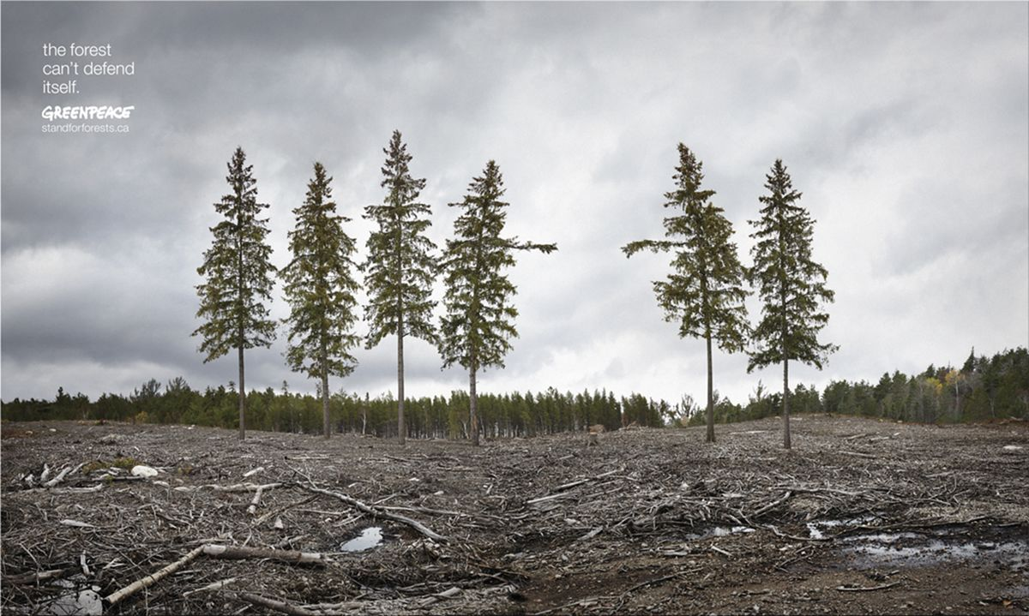
Appendix №2. – “Global Warming”
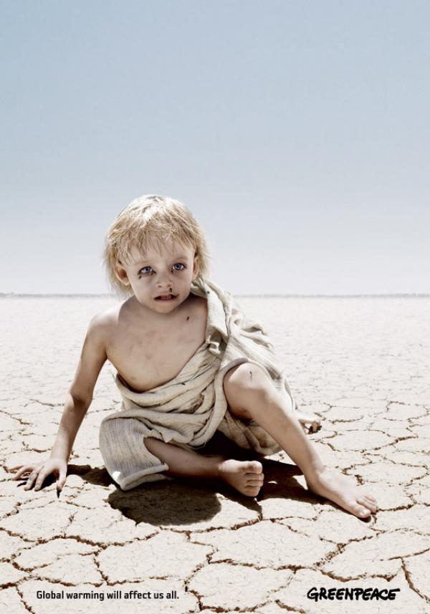
Appendix №3. – “Ocean Defenders, 2”
