Mathematics Internal Assessment:
An evaluation of the area of the shaded region of the Sierpinski Triangle in two cases: if it is an infinitely self-dividing fractal and if its repetitive pattern is hypothetically finite.
Date: 22nd of February, 2018
Word Count: 2,665

Contents:
1. Introduction to the topic and why this topic was chosen...............................................3
2. About the Sierpinski triangle and its formation.............................................................4
3. Aim of this exploration..................................................................................................5
4. Iterated function system.................................................................................................5
5. Area of the Sierpinski triangle if infinitely iterating......................................................5
6. Area of the Sierpinski triangle if finite...........................................................................7
7. Conclusion......................................................................................................................10

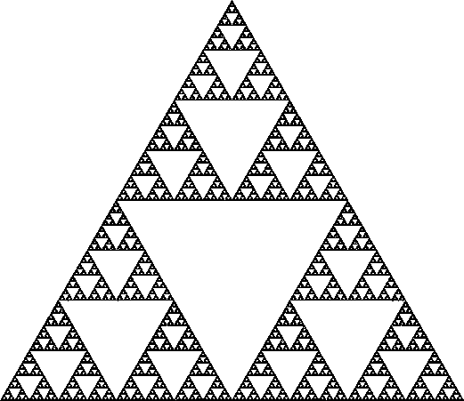
Figure 1. – The complete image of the Sierpinski triangle and its self-similar parts
When I think about maths, I never imagine numbers. I never imagine equations or functions or sequences. Instead I imagine shapes. When I think about maths, I think about geometry and how different shapes and figures might appear to be a part of everything that surrounds us. I am currently studying arts and a huge part of the work I do in the subject is related to geometrical shapes. Ever since I started developing my artworks I was almost subconsciously drawn to incorporating geometrical elements in them and it was as if my mind was constantly working on creating patterns of various different shapes, triangles in particular. The repetition of shapes is a concept that is encompassed in the field of fractal art. Fractal art by itself is a type of algorithmic art based on calculating fractal objects and representing those calculations as particular images and animations. There are several types of fractal art, depending on how the fractal objects within them are formed. The most common type of fractals use iterative transformations starting from a single shape, thus their mathematical inclination is tightly related to standard geometry. This exploration will focus on one particular example of this type of fractal art – the Sierpinski triangle, and will consider the different geometric features of the shape, as well as look more in depth into the possible ways of manipulating its implications.
The Sierpinski triangle, illustrated on Figure 1, is also referred to as the Sierpinski gasket and is a fractal image that has the overall shape of an equilateral triangle which is consequently subdivided into smaller equilateral triangles. What that means is that there is a pattern of division that repeats over and over again within the existing equilateral triangle. This pattern can potentially repeat forever. The construction of the Sierpinski triangle, as can be seen on the diagram below, begins with a single equilateral triangle whose surface is integrated and complete. The next stage involves “cutting out” a smaller equilateral triangle whose sides connect the midpoints of all the sides of the big triangle, thus its area would be equal to precisely $\frac{\text{1}}{\text{4}}$ of the area of the initial triangle. Then this is being repeated again and again within the remaining three triangles, which is the concept of iterating – repeating a process multiple times. In order to illustrate the Sierpinski triangle, the triangles that have been “cut out” are white in colour, while the remaining triangles, representing the substantial interior of the initial triangle, are in black. Over time it has been proven that the division can continue within each black triangle infinitely (Parsons 2014).
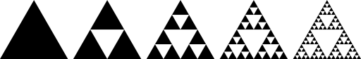
Figure 2. – 4 steps of iteration of the Sierpinski triangle, starting from a single bare equilateral triangle
Going back to the objective of this exploration, it aims to calculate the total shaded region, or interior, of the Sierpinski triangle, under two different conditions and then compare the results that have been obtained. The basic condition, which has been proven to be true, is that the pattern within the triangle keeps multiplying times infinity, thus the shape is a fractal with an infinitely iterating pattern. The second condition is theoretical and states that the pattern of the Sierpinski triangle will eventually stop iterating at a certain point in time and at a particular number of already performed divisions. This exploration will look at several potential variations of this condition in order to compare the difference between the results and how the number estimated for the area of the interior varies depending on how many times the pattern has been repeated.
In order to be able to grasp the extent of this exploration, one must be able to understand the formation of the Sierpinski triangle, which as simple as it seems, has a hidden complexity to it. One way to explain it is following the algorithm of the Iterated Function System, outlined by British mathematician Michael Barnsley, who had specialized in studying fractal compression. This algorithm is a common technique for generating any fractal structure and works on the principle of making multiple copies of the same element over time, each of those copies being transformed by a particular function. An Iterated Function System by itself is a finite set of the so called “contraction mappings”, however, in the case of the Sierpinski triangle, the copies of the initial equilateral triangle repeat within the smaller equilateral triangles ad infinitum, or endlessly. That is why the Sierpinski triangle has a self-similar fractal nature or structure (Riddle 2017).
Calculating the total shaded area of the fractal would require knowing how many times the pattern of division has repeated within the figure. If the factual statement that the divisions within the Sierpinski triangle happen repeatedly and infinitely without a stopping point has been taken as true, that would mean that the triangles will keep iterating times infinity. In order to calculate the area of the interior of the Triangle, we need to consider the area that has been removed, or the white parts if we look at Figure 1 and 2. Since each new contraction is marked by a function and the operation between the functions is multiplication, we are dealing with an infinite geometric sequence. If we accept that the total area of the Sierpinski triangle, including both the shaded and the non-shaded regions is equal to x, then the area of the “removed” triangle at the division of the initial equilateral triangle will be equal to $\frac{1}{4}$x. This step is illustrated on Figure 3. Analogically, the total area of the next few “cut out” triangles will be $\frac{3}{16}$x, as seen on Figure 4, since three more triangles are removed. After another repetition of the same pattern, the non-shaded area will be equal to $\frac{9}{64}$x, and after yet another one - to $\frac{27}{256}$x, as demonstrated on Figures 5 and 6. If we express those values as an actual orderly sequence, it will look like the following: $\frac{1}{4}$x$, \frac{3}{16}x$, $\frac{9}{64}x$, etc. We can now clearly see that the values are being multiplied by a common ratio of $\frac{3}{4}$, which proves and additionally supports the idea of using a geometric sequence to calculate the non-shaded area of the Triangle and consequently the shaded one. This also implies that the series has no last term (Wu 2013). Before substituting with the mentioned values of the terms of the sequence, let’s take into consideration that the formula for the sum of an infinite geometric sequence is such that:
$$S_{∞}= \frac{u_{1}}{1-r}$$
where u₁ is the first term of the sequence, and r is the common ratio, which in order for the formula to be used has to have a magnitude lower than one: a condition satisfied in this case. The first term is already known to be equal to $\frac{1}{4}$x and the common ratio can be calculated by dividing any term of the sequence by the one before, which, once again, gives the fraction of $\frac{3}{4}$. If all of those values are substituted in the formula for an infinite geometric sequence, the following equation will be obtained:
$$S_{∞}= \frac{\frac{1}{4}x}{1-\frac{3}{4}}$$
Figure 3.
Figure 4.
Figure 5.
Figure 6.
After solving the equation, it turns out that S∞ is in fact equal to simply x. This result might seem rather surprising, since it shows that the initial area of the single triangle is equal to the total area of all the “removed” triangles ad infinitum. This is supposedly happening due to the fact that even though we have accepted the fact that the pattern within the Sierpinski triangle is to repeat infinitely, the area of the shaded region will eventually equate the total area “removed” from the triangle. Let’s take that the original area of the equilateral triangle before the occurrence of any division was equal to 1. This would mean that the area of the non-shaded region will also be equal to 1, thus causing the value for the area of the shaded region to approach 0, since at each step a piece of the total area of the initial triangle has been taken away. We can use calculus to represent this relationship:
$$\lim_{n→∞}{{\left(\frac{3}{4}\right)}^{n}}=0$$
That is, we are using the fraction $\frac{3}{4}$ raised to the power of n, since the fraction is the common ratio that n is the number of iterations and the so called “limit” of n is the last value it can take. In this case, since the Sierpinski triangle is a fractal with an infinite number of iterations, the limit of n is infinity. Thus, in return, the area of the shaded region will approach 0, and the shaded region is the total area minus the non-shaded region, which written as a term of a sequence is $\frac{3}{4}$, since the analogical number for the shaded region is $\frac{1}{4}$ (Riddle 2017). The limit of the function can be also visually represented on a graph (Figure 7), where 0 is the horizontal asymptote and we can clearly see that as n increases and approaches infinity, the value of the function approaches 0.
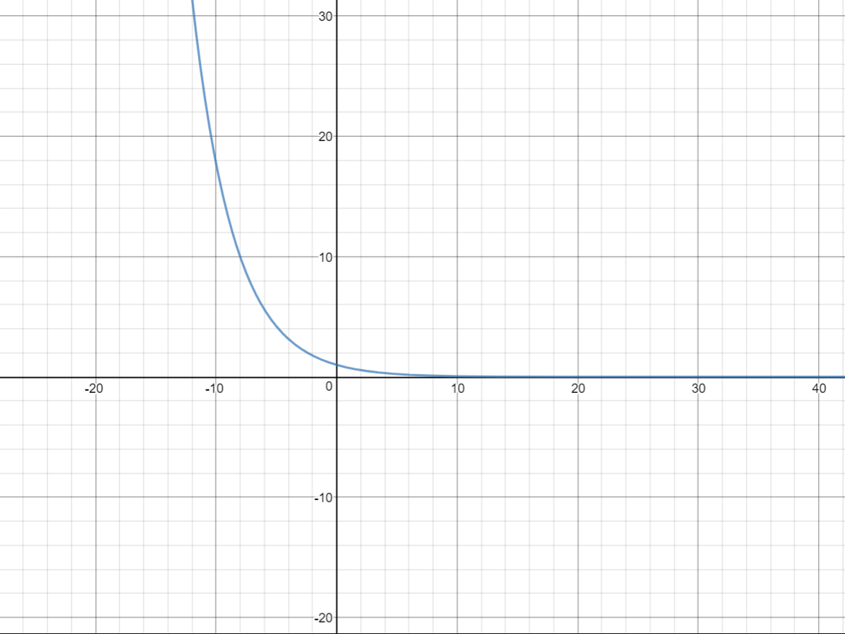
Figure 7. A graph of the function ${\left(\frac{3}{4}\right)}^{n}$, for which the horizontal asymptote is equal to 0 (Desmos Graphing Calculator 2015)
Having obtained the area of the shaded region of the Sierpinski triangle given that its iterating pattern is infinite, one might wonder what would change if the pattern stopped iterating and the number of triangles “cut out” from the original big triangle remained constant. This is a concept that if explored, will transcend the idea that the Sierpinski triangle is an infinitely iterating fractal. In order for a result to be provided for this theoretical situation, a particular number of fixed iterations needs to be set. Lets say that the Sierpinski triangle stops contracting or dividing within itself after 5 already performed repetitions. This signifies that one additional step will be taken after the last one shown on Figure 2. The area of the shaded region of the fractal image, as explained before, is directly related to the area of the non-shaded region through the following formula
$$x=A_{s}+A_{n}$$
where x is the total area of the initial equilateral triangle, A_{s} is the area of the shaded region and A_{n} is the area of the non-shaded region. Thus, in order to find the area of the shaded region obtained after 5 iterations, we need to subtract the area of the non-shaded one from the total area – x. Finding the non-shaded region requires the use of a simple geometric sequence is required, the formula for which is the following:
$$S_{n}=\frac{u_{1}(1-r^{n })}{1-r}$$
where n represents the number of terms in the sequence, or in this case the number of pattern repetitions within the Sierpinski triangle, u₁ is the first term in the sequence that we found before, and r is the common ratio. If we substitute for each of the mentioned elements, we will eventually end up with an equation that shows that
$$S_{5}= \frac{\frac{1}{4}(1-({\frac{3}{4})}^{5})}{1-\frac{3}{4}}$$
After simplifying we’ll receive that
$$S_{5}=1-\frac{243}{1024}$$
which when calculated and rounded to three significant figures for a more accurate account will give the decimal number of approximately 0.76. This is the number representing the total non-shaded area of the Sierpinski triangle if it stops iterating after the 5th iteration. The next step is subtracting that number from the total area if no triangles have been “cut out”. Let’s consider that this area is once again equal to 1. This will mean that the shaded area will equate to
$$A_{s}=1-0.76$$
which gives the number 0.24, which is an irrational number that is relatively close to 0. A prediction that can be made is that with the increase of potential repetitions of the division pattern within the Sierpinski triangle, the value of the area of the shaded region will decrease and gradually approach 0, since more and more of the interior of the triangle will be removed. In order to test this ‘hypothesis’ and compare the gradient of the change of the area value, let’s explore what will the area be if the triangles stop dividing after the 7th and the 9th iteration. Analogically following the same method and formula as before, the sequence in the case with 7 iterations after substitution will look like
$$S_{7}=\frac{\frac{1}{4}(1-({\frac{3}{4})}^{7})}{1-\frac{3}{4}}$$
which after performing all the operations equals to approximately 0.87. When subtracting it from the total area of 1, we will receive the number 0.13 for the area of the non-shaded area after 7 repetitions of the pattern, which is significantly closer to zero than the one after 5 repetitions. Finally, let’s consider that the triangles within the Sierpinski triangle stop iterating after the 8th iteration. If we insert the data for this condition within the formula for the sum of a geometric sequence we will then receive that
$$S_{9}=\frac{\frac{1}{4}(1-{(\frac{3}{4})}^{9})}{1-\frac{3}{4}}$$
which gives as a result the number 0.92, which shows that a larger area of triangles has been removed from the total area. When that number is subtracted from the total area of 1, the number 0.08 is obtained for the non-shaded region at this point. To better understand the gradient of change of the area, it is beneficial to compare all the values that were acquired:
 | After 5 iterations | After 7 iterations | After 9 iterations | After 10 iterations | After 11 iterations | After 30 iterations | After 90 iterations
Value of area of non-shaded region | 0.7627 | 0.8665 | 0.9249 | 0.9437 | 0.9578 | 0.9998 | 1
Value of area of shaded region | 0.2373 | 0.1335 | 0.0751 | 0.0563 | 0.0422 | 0.0002 | 0
Figure 8. – A table showing the value of the areas of both the shaded and the non-shaded region of the Sierpinski triangle at seven different phases
Figure 8 shows the value of the area of the shaded and the non-shaded region of the Sierpinski triangle after 5, 7, and 9 iterations as already calculated, and then analogically, following the same algorithm – the same values after 10, 11, 30, and 90 iterations. The presence of values at several different stages allows us to get a more accurate idea of the gradient of change of the value of the two areas. We can observe that after each consecutive iteration, the value of the area of the non-shaded region of the Sierpinski triangle increases at the expense of the area of the shaded region, which decreases and, as predicted gradually approaches, and eventually reaches 0. At the 30th iteration we can see that the value of the area of the shaded region is extremely small, however it still hasn’t reached zero. Then, at the 90th iteration it is clear that the non-shaded region has reached a total area of 1, leading to the area of the shaded region reducing to 0. A conclusion can be drawn that the hypothesis was true and the data calculated supports the idea that if the Triangle’s pattern repeats infinitely, its shaded area will eventually reach the value of 0 as area keeps getting lost after each self-division of triangles. On Figure 9 we can see a line graph that shows the correlation between the change in the value of the area of the shaded and the non-shaded region of the Triangle. The two variables share an inverse correlation.
Figure 9. – A line graph showing the gradient of change of the value of the area of the shaded and non-shaded region of the Sierpinski triangle given that the initial total area is equal to 1
Taking into consideration all the results that were obtained throughout this exploration, it was proven that the Sierpinski triangle, despire being a fractal with an infinite amount of possible iterations, will eventually lose all of its interior as its initial area equals the total area removed from it. The objective of the exploration was achieved, since it showed how the shaded region of the Sierpinski Triangle changes as the fractal continues to iterate over time. We can connect the iterations within the triangle to the idea of exponential functions, since What the results demonstrated can be taken as an example of how something as simple as an equilateral triangle can have far more sophisticated applications if involved into something larger and incorporated into a concept with a larger scope.
Works Cited
“Desmos Graph.” Desmos Graphing Calculator, Desmos, 2015, www.desmos.com/calculator.
Lippman, David. Area and Perimeter of a Sierpinski Triangle. YouTube, YouTube, 28 June 2011, www.youtube.com/watch?v=5plLxMnbtAw.
Parsons, Marianne. “Pascal's Triangle and Modular Exploration: Sierpinski Triangle.” Jwilson, 2014, jwilson.coe.uga.edu/EMAT6680/Parsons/MVP6690/Essay1/sierpinski.html.
Riddle, Larry. “Area of the Sierpinski Gasket.” Sierpinski Gasket Area, Agnes Scott College, 20 June 2017, ecademy.agnesscott.edu/~lriddle/ifs/siertri/area.htm.
Riddle, Larry. “Classic Iterated Function Systems.” Iterated Function Systems, Agnes Scott College, 23 June 2017, ecademy.agnesscott.edu/~lriddle/ifs/ifs.htm.
Wu, Titus. “A Sierpinski Triangle Problem.” Whatever Comes To Mind, WordPress, 21 Mar. 2013, tituswuphiloblog.wordpress.com/2013/03/21/a-sierpinski-triangle-problem/.

