English L&L HL
Written Task #2 on Reader, Culture, and Text
Based on Donald Trump’s Controversial Posts on Social Media
2/25/2018

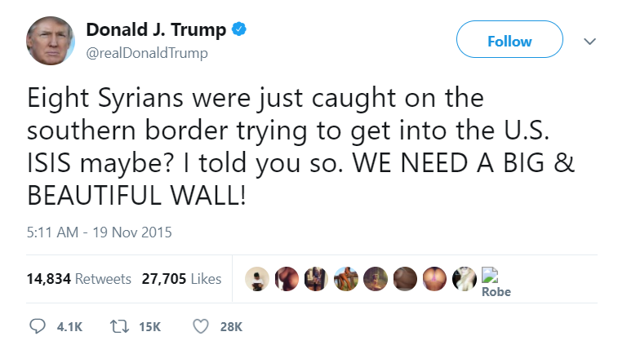
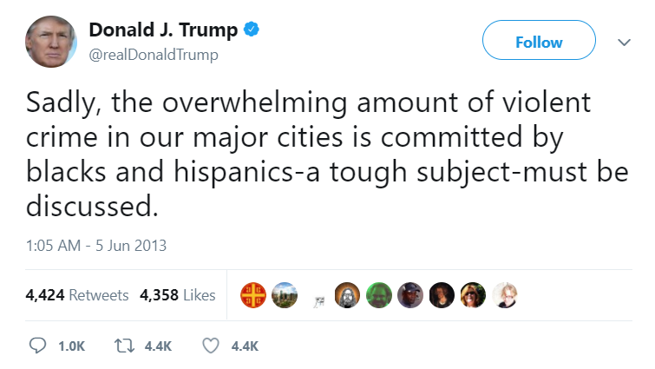
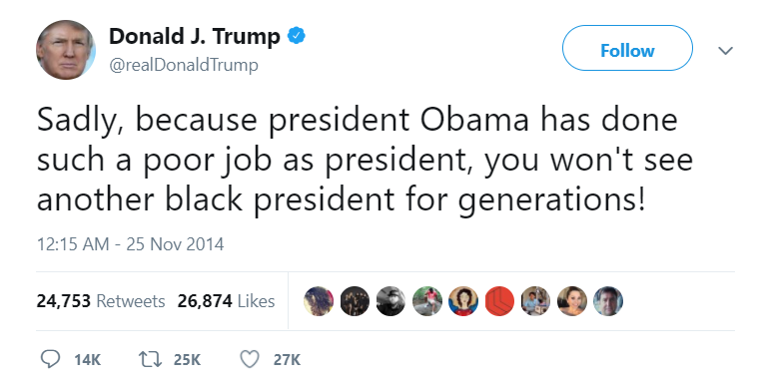
Outline
Prescribed question: How could the text be read and interpreted differently by two different readers?
Part of the course to which the text refers: Language and mass communication
Texts for analysis:

This critical response will:
1. Analyze the language used in Donald Trump’s tweets and its implications
2. Establish the context of the tweets, as well as the one of the two audiences: White Americans vs. African-Americans
3. Identify issues related to racism and discrimination presented through provocative words and phrases within the tweets and how those might be interpreted by the two audiences

The 45th President of the United States – Donald Trump, whose election took place in the fall of 2016, has ever since been a subject of serious controversy both within and without the country itself due to his scandalous behavior and discriminative attitude towards minority groups. Despite having won the election by winning the Electoral Vote, it somehow seems that the majority of people in the United States are unhappy with Trump’s presidency. Similarly to previous governors, Trump maintains a strong social media presence, especially in the Twitter network where he shares his opinion on the most recent events and topics by “tweeting” about them. However, there is something that makes Trump’s social media posts different than the rest: he uses provocative, highly informal language and openly criticizes other public figures such as the former president of the States – Barack Obama. Many of Trump’s tweets are of a particularly racist nature, targeting minorities and African American people living in the United States in specific. Due to this reason, this commentary will respond to Trump’s tweets through the lens of an audience of White Americans and one of African-Americans, juxtaposing the potential interpretations and reactions of the two.
In the three particular tweets chosen for this response, Trump is either implicitly or explicitly expressing his negative attitude towards African-American people. He is further referring to their presence in the country as “a tough subject”, or a problem that has to be discussed and eventually mitigated through the radical act of building a wall between the United States and Mexico. According to Trump’s prospects, a solution to the problem of immigrants entering the States and causing trouble is in fact building a wall between the two countries, which explains the reference he’s making in the third tweet. It all eventually links back to Trump’s personal outlook on racial differences and his feelings towards having African-Americans coexist with White Americans.
The context of a White American differs to a great extent from the one of an African-American. While White Americans are considered native and have lived in the United States peacefully, African-Americans have been subjects of discrimination and oppression since ages. Further, the presidency of Barack Obama and the fact that he was one of them helped African-Americans gain confidence and become more integrated in the society, making the transition from the former to the new president an extremely difficult one. An African-American’s interpretation of Trump’s tweets would thereby be predisposed by Trump’s overall demeanor and the fact that he publicly antagonizes African-Americans, forcing his opinion upon all of society. The interpretation of a White American on the other hand would probably depend on his own attitude towards African-Americans, however many White Americans are also likely to conform to Trump’s opinion, simply because he’s in power and it is easier to agree with the authority than to oppose it.
The language Trump uses in his tweets has several main characteristics: it is colloquial, sarcastic, and highly provocative. The level of informality and simplicity of the words and phrases he uses would typically be considered inappropriate for any government official. However, this language in particular suits Trump’s purpose of seeming closer to the public and presenting himself as a genuine member of the society rather than someone of a relatively higher rank. He can thus address all levels of the society and make an impression that would ensure he’s heard and understood better. In the first tweet, Trump is directly commenting on Barack Obama’s presidency, imposing his opinion that he has done “a poor job” out of it, blaming it on Obama’s race and using generalization to make predictions. Firstly, by using the word “sadly” to begin the tweet, Trump is being sarcastic about feeling regretful that the United States “won’t see another black president for generations.” If a White American was to read this tweet, his interpretation would depend on whether he was content with Obama’s presidency or not. A strong supporter of Obama would feel irritation and disagree with Trump’s subjective, disrespectful opinion. An African-American’s reaction to the tweet would be probably way sharper, since African-Americans are typically strong supporters of Obama and would feel personally offended by the way Trump is referring to him.
Trump’s second tweet is of a similar nature and again begins with the word “sadly”, implying sarcasm and a mocking remark. In this tweet he is making a reference to “blacks and hispanics” being the racial classifications to commit most of the “violent” crimes in major US cities. Trump is once again being subjective, using generalization and presenting information that sounds particularly unreliable since it is not supported by evidence of any sort. The word “violent” is especially vague and used without context or explanation. All of this makes it seem as if Trump is simply speculating and looking for a reason to begin discussion of how to ban minorities from entering the States. This tweet is powerful in a way that it can twist the mindset of a White American and force him to believe in the criminal tendency of minorities. However, not all White Americans are as easily persuaded and it all depends on their personal view system. An African-American would once again feel offense reading this tweet, as well as fear from the results of the potential discussion Trump is talking about.
In the last tweet, Trump again presents a hypothetical situation that has happened but without providing evidence, and then makes an allusion to the ISIS terrorist organization. He is thus encouraging stereotypical generalization and enforcing an image of Syrians that severely stigmatizes their population. His purpose is however to impose his idea of building a wall, and he achieves it using mockery and sarcasm. A White American would probably not have such a strong reaction to this tweet, however it all depends on how prone to manipulation he is. An African-American would sympathize to the way Syrians are presented and feel bitterness towards Trump’s acrimony.
Word Count: 992

Works Cited
Trump, Donald J. (realDonaldTrump). “ Sadly, because president Obama has done such a poor job as president, you won't see another black president for generations!” 25 November 2014, 12:15 AM. Tweet.
Trump, Donald J. (realDonaldTrump). “ Sadly, the overwhelming amount of violent crime in our major cities is committed by blacks and hispanics-a tough subject-must be discussed.” 15 June 2013, 1:05 AM. Tweet.
Trump, Donald J. (realDonaldTrump). “Eight Syrians were just caught on the southern border trying to get into the U.S. ISIS maybe? I told you so. WE NEED A BIG & BEAUTIFUL WALL!” 19 November 2015, 5:11 PM. Tweet.
Washington, Jesse. “African-Americans See Painful Truths in Trump Victory.” The Undefeated, The Undefeated, 10 Nov. 2016, theundefeated.com/features/african-americans-see-painful-truths-in-trump-victory/.

